Karthik Pradeep Hegadi

**2KE20CS032**

**Assignment 11**

*Understood. To follow the provided instructions and create the files/directory using the same name and case as provided in the task steps, please provide me with the specific names and case instructions for the files/directory you want to create.*

SHELL SCRIPTING

---------------------------------------------------------------------------------------------------------------------------

**Shell scripting assignment 01**

**Script1.sh**

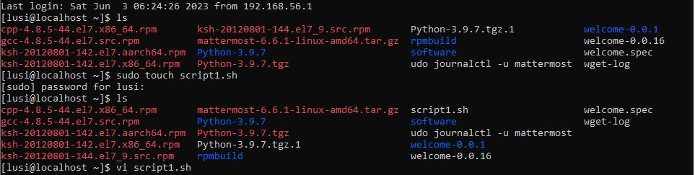

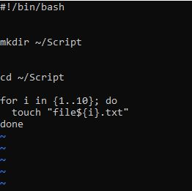

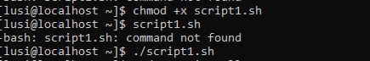

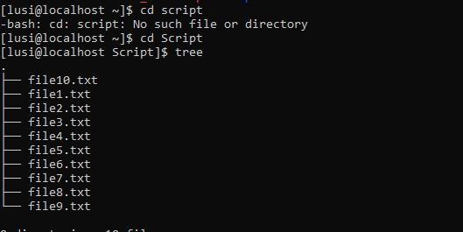

**Script2.sh**

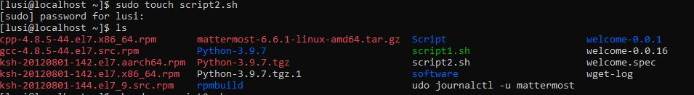

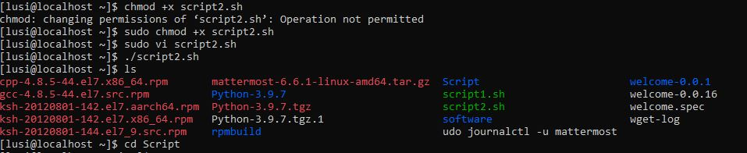

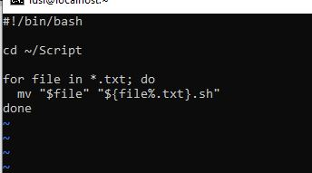

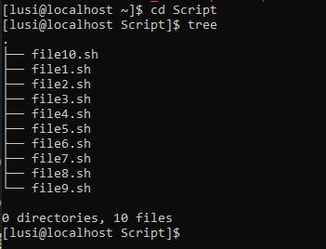

**Shell scripting assignment 2 -automate the backup files**

Step 1 : I will make a directory in which I do have all my important files which I will be taking back up





I will make some few directories (because I don’t want to take full machine as a backup only this important folder )

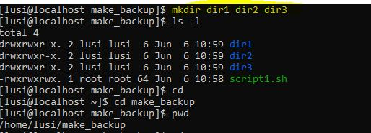

Step 2 : create a script file which will be having script code for backup



Script will ask the user to provide the specific absolute path for backup the things

And it also ask for the ip address to move the tar file from one machine to another

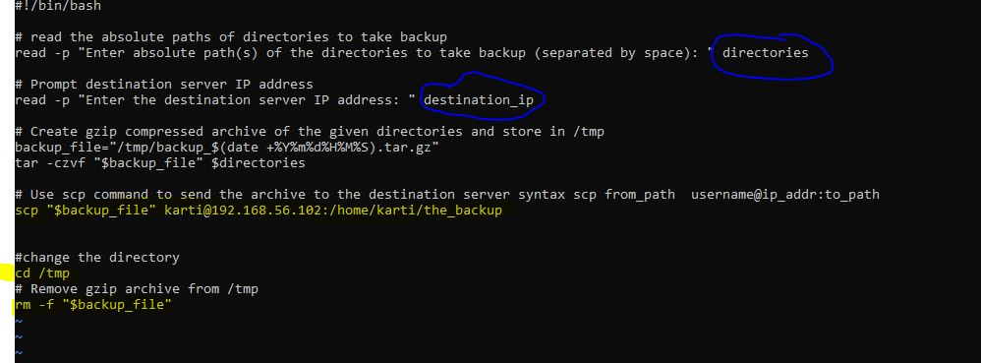

I am creating the clone of machine which is safe for coping the things(this machine will act as the destination server )

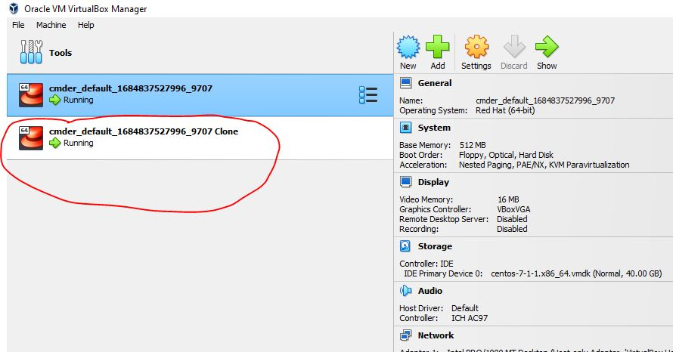

Ip address of the new machine which is different from the old machine because each machine will act as different to know the OS to transfer the file

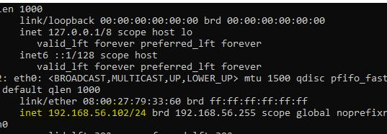

As mentioned early that the using root user we cant perform any thing thus I created the new user as kartii in destination server

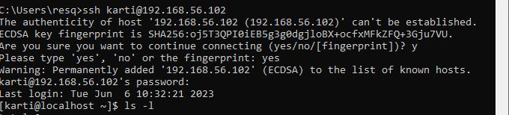

And created the new backup folder which acts as the destination folder for backup the thing

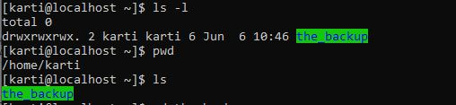

Step 3 from the 1st machine I will run the script which was above mentioned

After running the script the file is fully copied from machine one to another machine 2

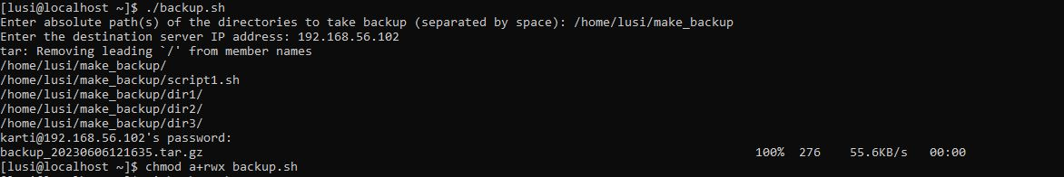

Poof of deleting the tar file from path /tmp/

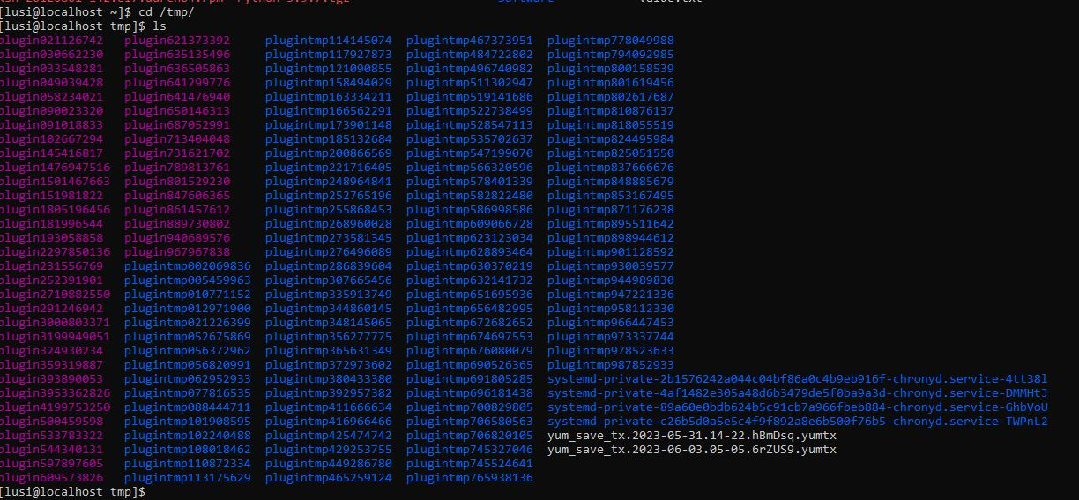

Step 4 : final image of copied thing

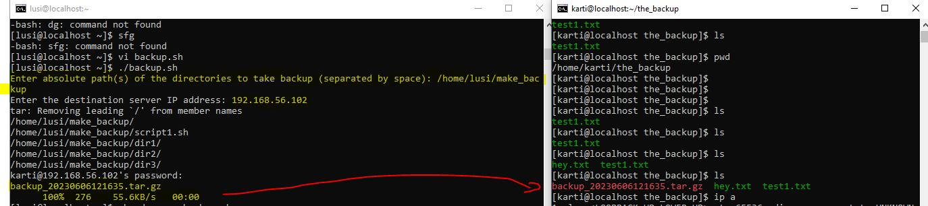

**Assignment 3**

Pre_request:

As mentioned its not required to use the script to create folder but its hectic to create thus I used the script

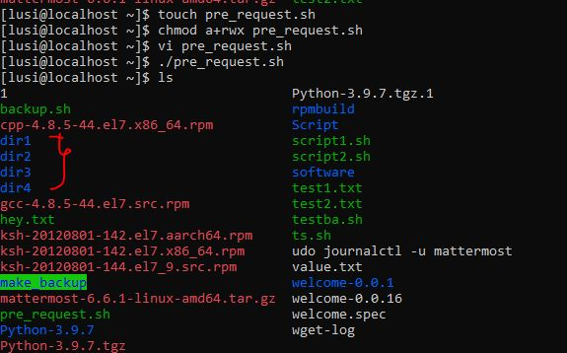

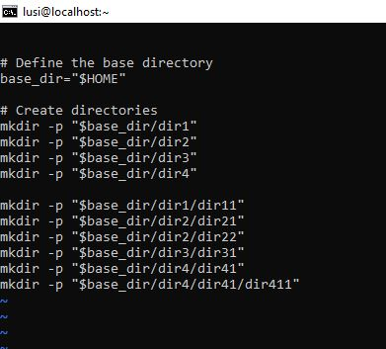

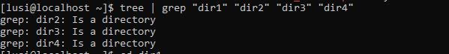

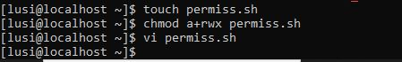

I took some as text and some as list files

Note some files have 777 permissions and some have different as mentioned

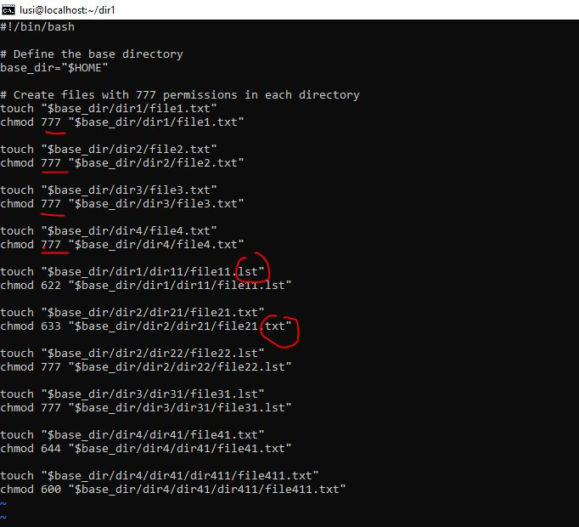

Proof of created

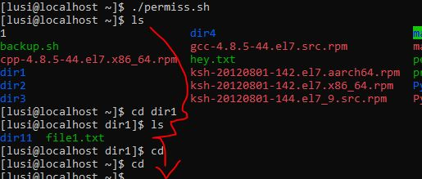

Creating soft links

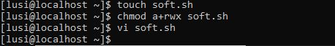

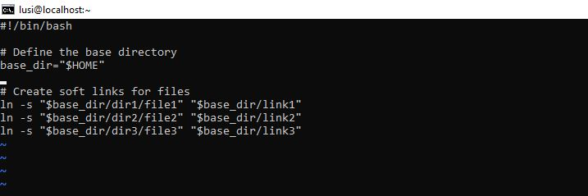

Run it



Proof of created soft links

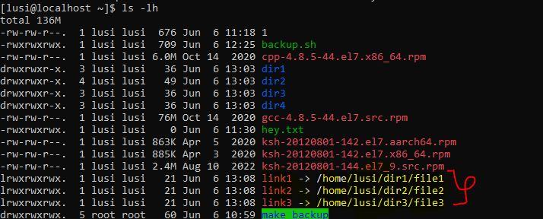

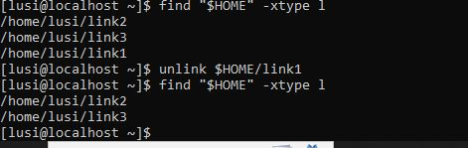

This script will check the permission which have 777 and deletes which I have created previously

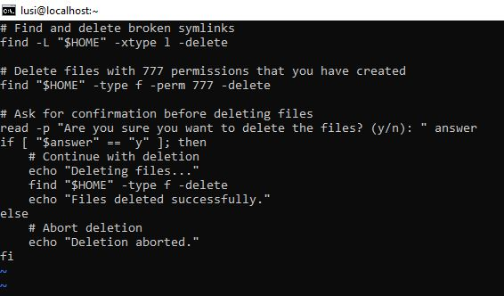

Running the script Deleting

And its asking the permission to delete the files



Assignment 4 sql dump using shell script

Make a directory and gives the permission to write because here in this folder the mysql will try to write the files that’s y

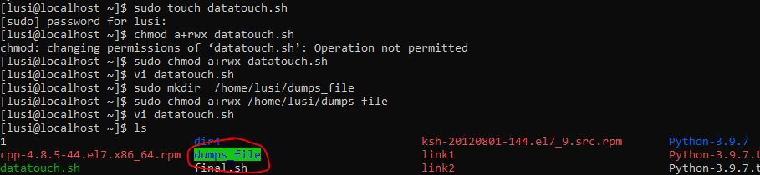

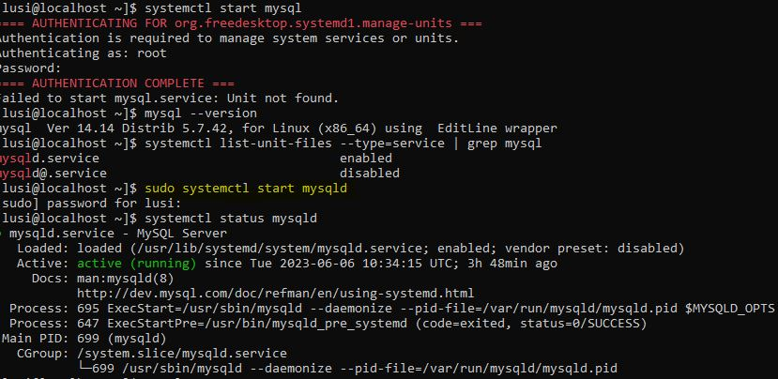

Script 1

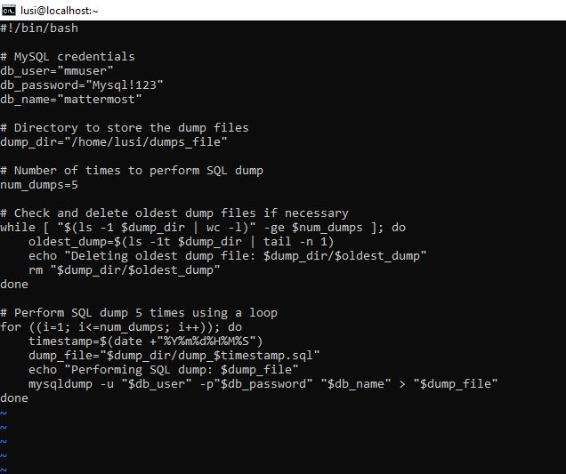

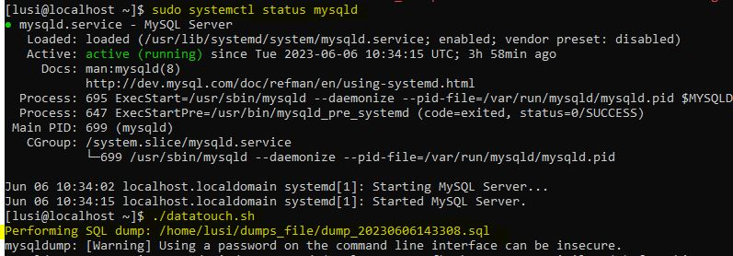

Proof how its dumps the things keenly

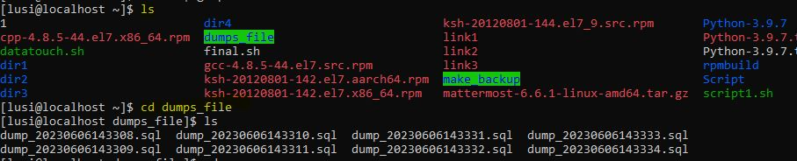

Completed:-

For last assignment I have use another script too even that worked well for me

Which is given below

